## Preliminary Step 1:

* Create an excel file with all contacts’ phone number.

Please follow the requirements as mentioned:

* Excel Book name **MUST** be saved as “XLContactsList”
  + Excel sheet name **MUST** be “**Sheet1**”
  + Sheet should contain phone numbers **ONLY**
  + Phone numbers are to be contained in Column **A** **ONLY**, proceeding down the column, with the first number being in cell A1

**Example:**

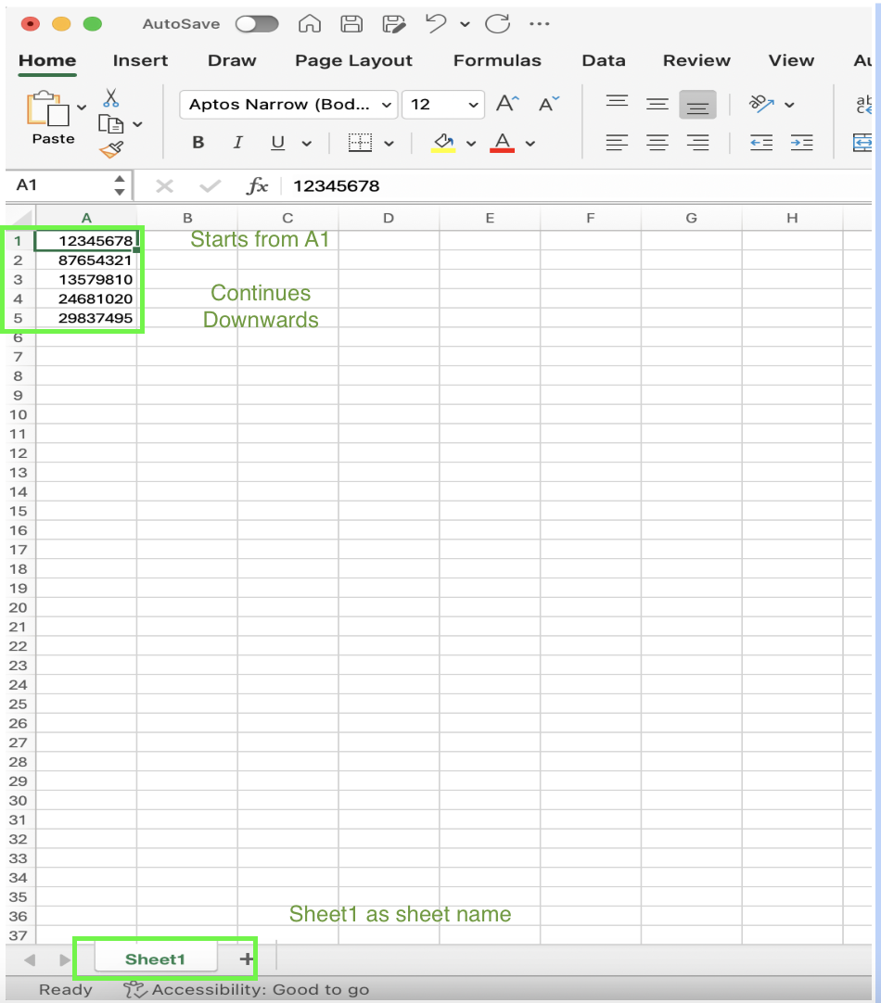

## Preliminary Step 2:

* Go to this page: <https://nodejs.org/en/download/prebuilt-installer>

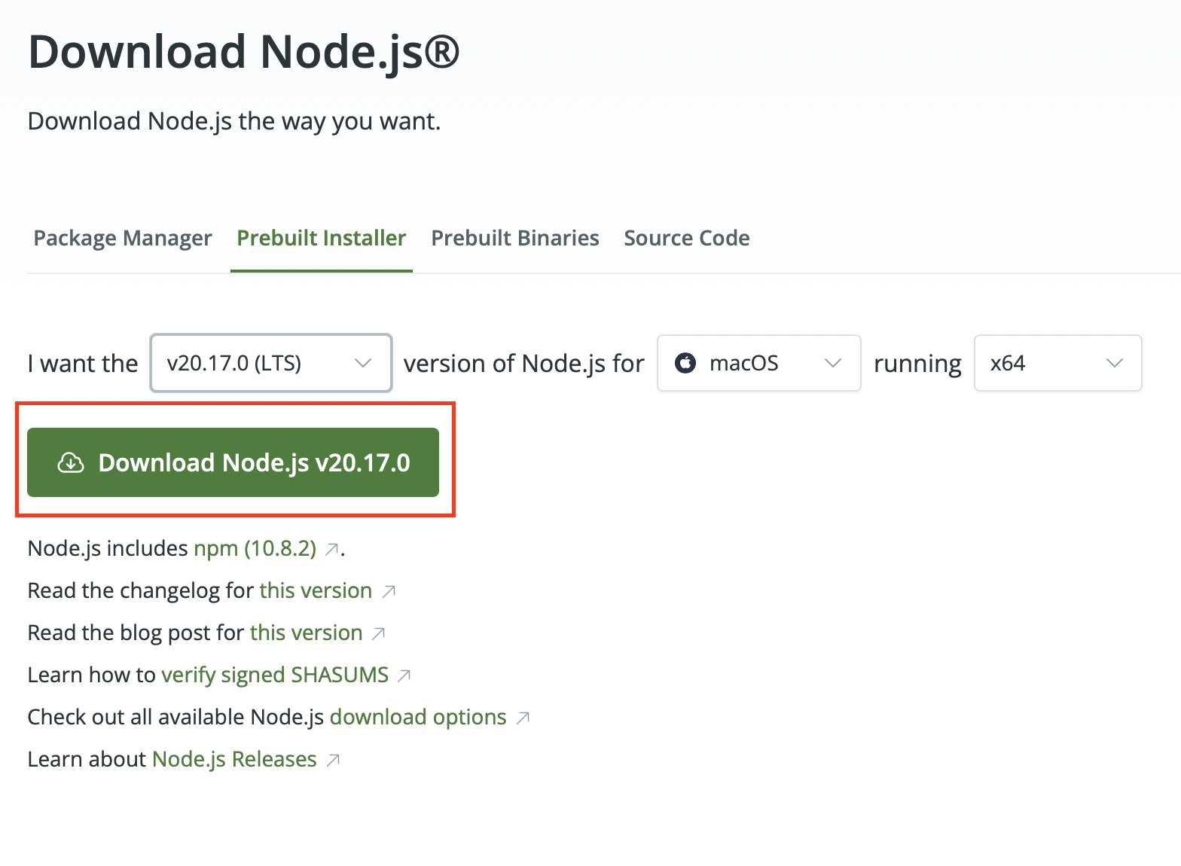

* Check the options in the pulldown bar **CAREFULLY!** 
  + “I want the v20.17.0 (LTS)” “for (your computer system)”

“running x64 (arm64 if you are using M1/M2/M3 Mac)

* Open the downloaded exe file and step through the installation process

## 

## Preliminary Step 3:

You should have received a folder with the file “wwauto.js” within it

#### If you are using Apple based computer:

* Open Finder and navigate to the folder which contains “wwauto.js”
* Open the folder
* At the bottom of the page, you should see something like this:



* Right click “wwauto” 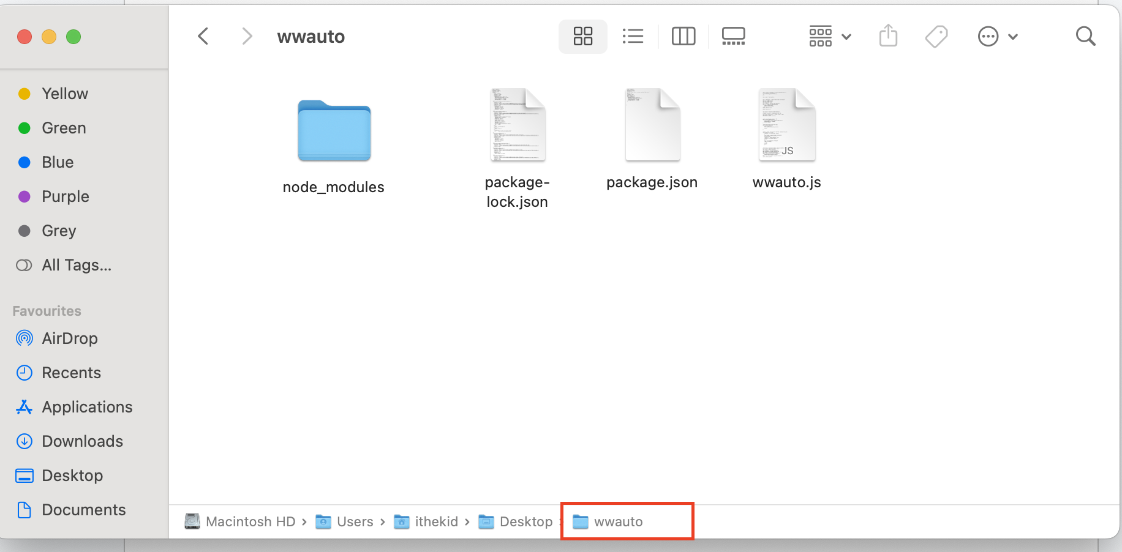
* It should bring up a pulldown bar. Select “open in terminal”

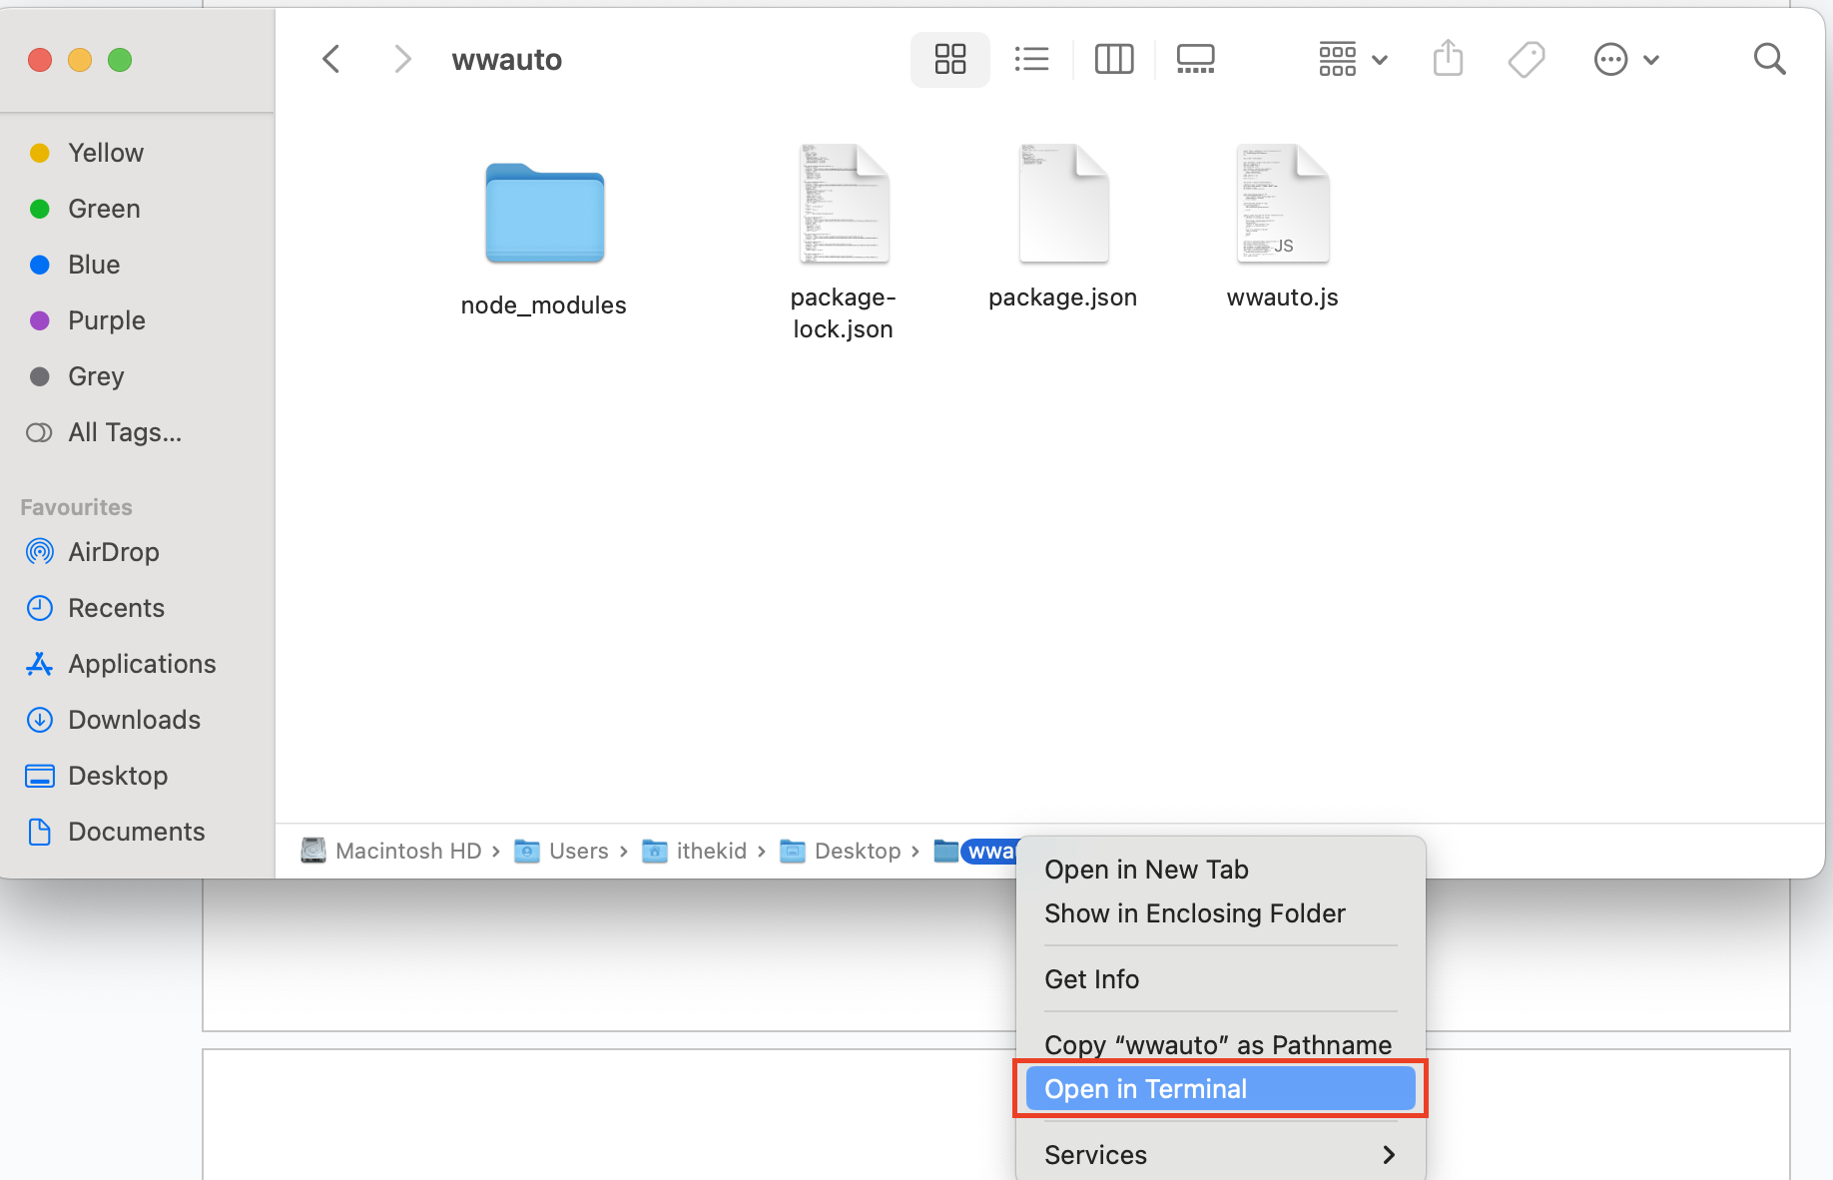

* A terminal like this should show up:

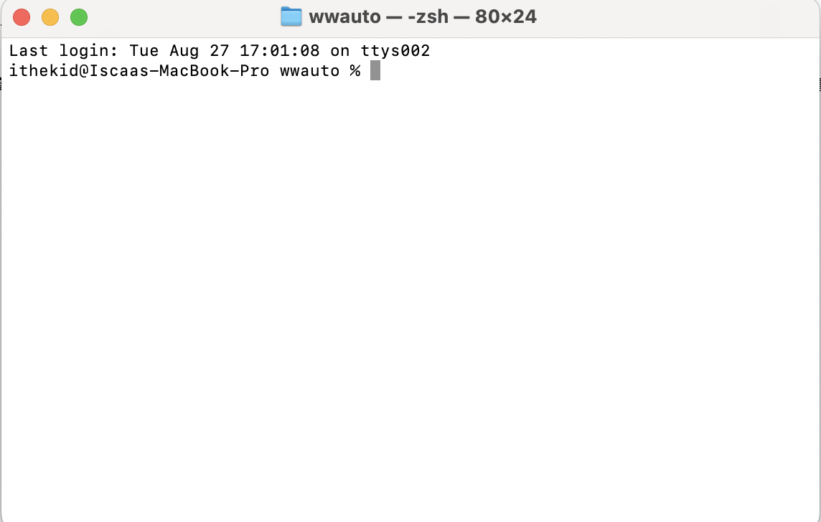

* In the terminal, type “npm i whatsapp-web.js” and press enter
* Allow it to run, when it finishes, something like this will show up:

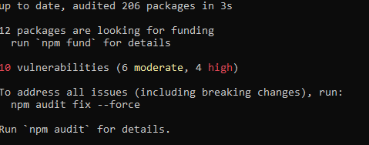

* After seeing these lines, type “npm i macos-open-file-dialog”. And press enter
* After that, type “npm i qrcode-terminal” and press enter
* After that, type “npm i exceljs” and press enter
* Finally, type “node wwauto.js” and press enter.

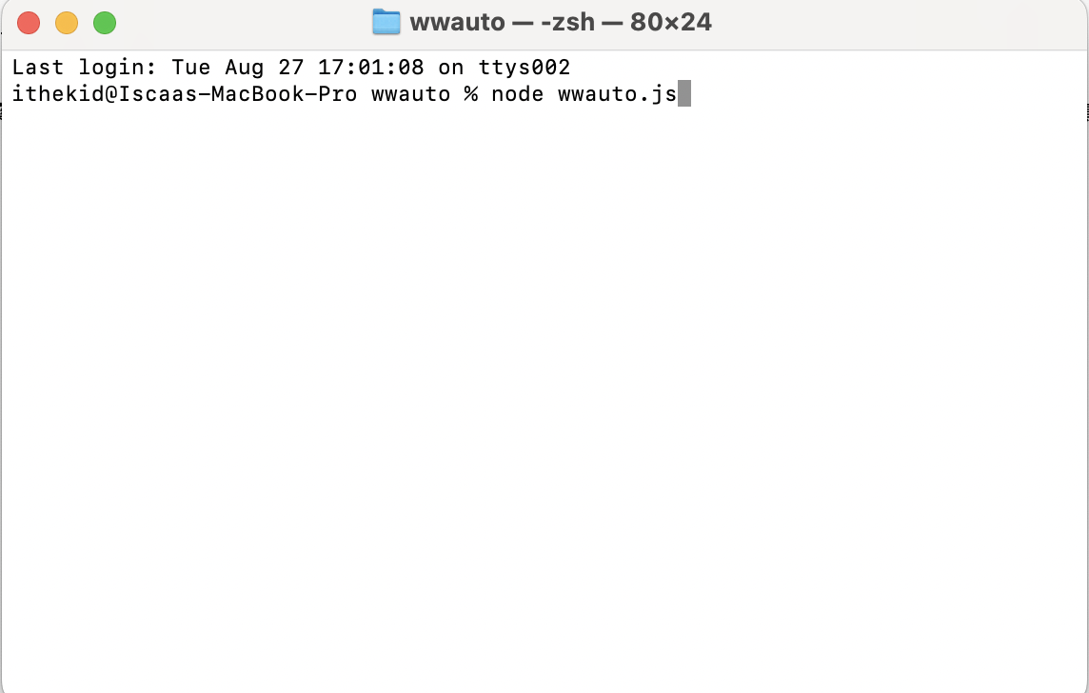

* A file selection screen should pop up, select the excel file you made previously
* Upon selecting the excel file, a QR code will pop up in the terminal
* 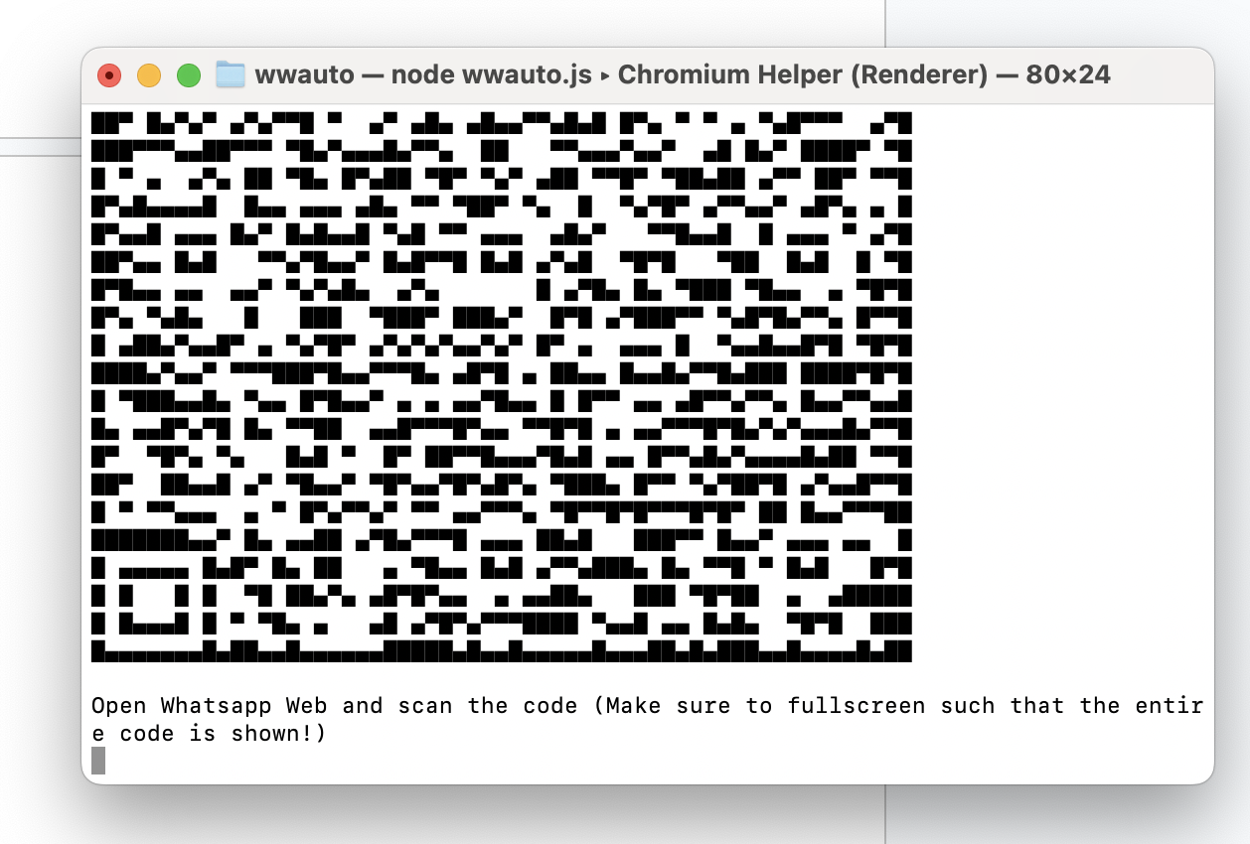

#### 

#### 

#### If you are using Windows computer:

* Open file explorer, and move the excel file you just created into the file which contains “wwauto.js”

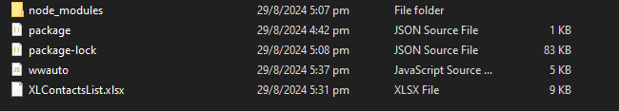

* Left click the top bar of the file dialog:

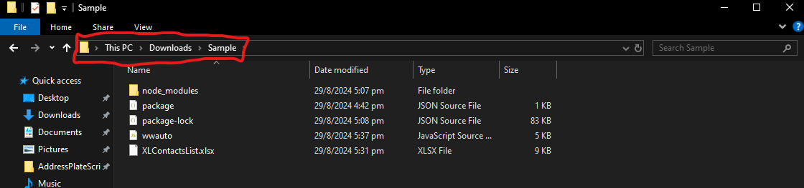

* The bar should be highlighted

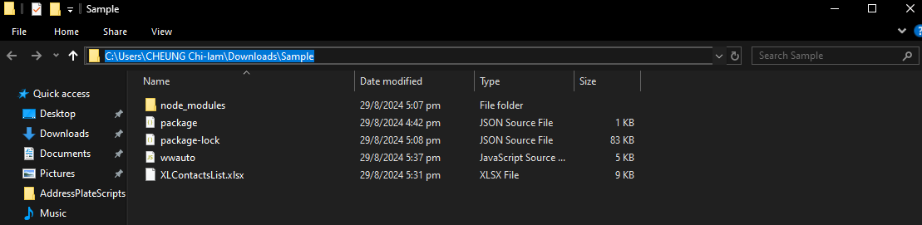

* Type “cmd” and press enter. A terminal should show up:

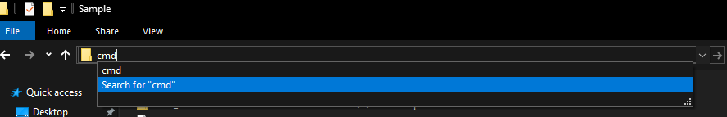

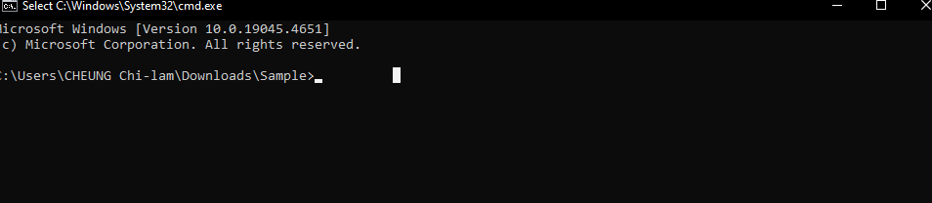

* In the terminal, type “npm i whatsapp-web.js” and press enter
* Allow it to run, when it finishes, something like this will show up:



* After seeing these lines, type “npm i macos-open-file-dialog”. And press enter
* After that, type “npm i qrcode-terminal” and press enter
* After that, type “npm i exceljs” and press enter
* Finally, type “node wwauto.js” and press enter.
* A QR code should pop up in the terminal

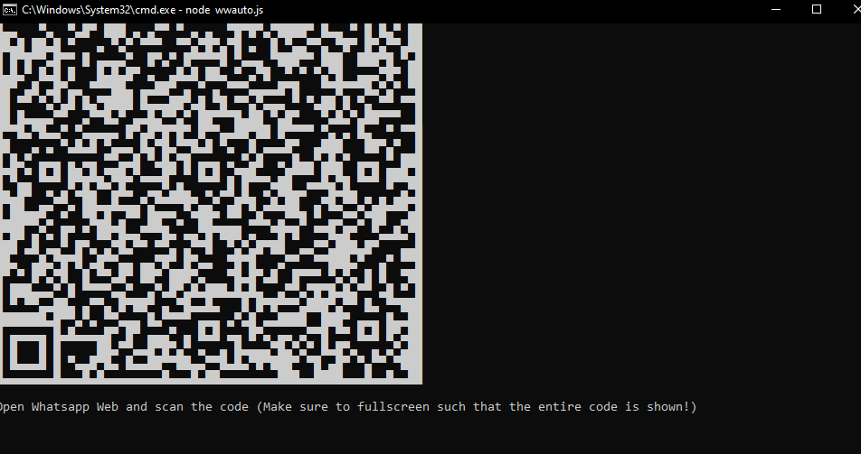

## Step 1:

* Fullscreen the terminal
* Using Whatsapp Web on the workphone, scan the QR code to login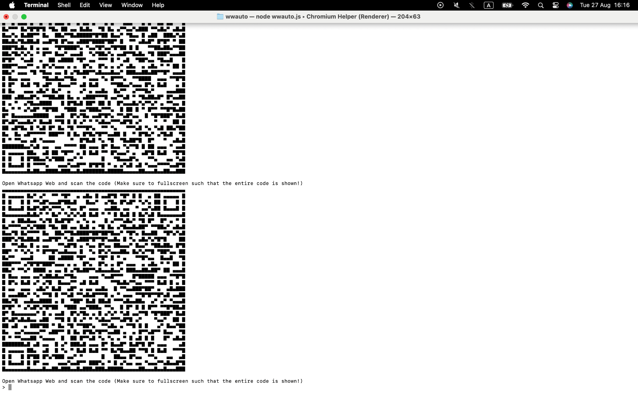
* The QR code will refresh every few seconds, scan the most recent (bottom) one
* If the code does not scan right away, try tilting the phone in different angles until it does

## Step 3:

* After scanning and confirming connection on whatsapp web, this message will show:



* Prepare the template message and modify it by adding ‘!check’ in front of it:



* Using your own phone/another phone, send the modified message to the workphone using whatsapp

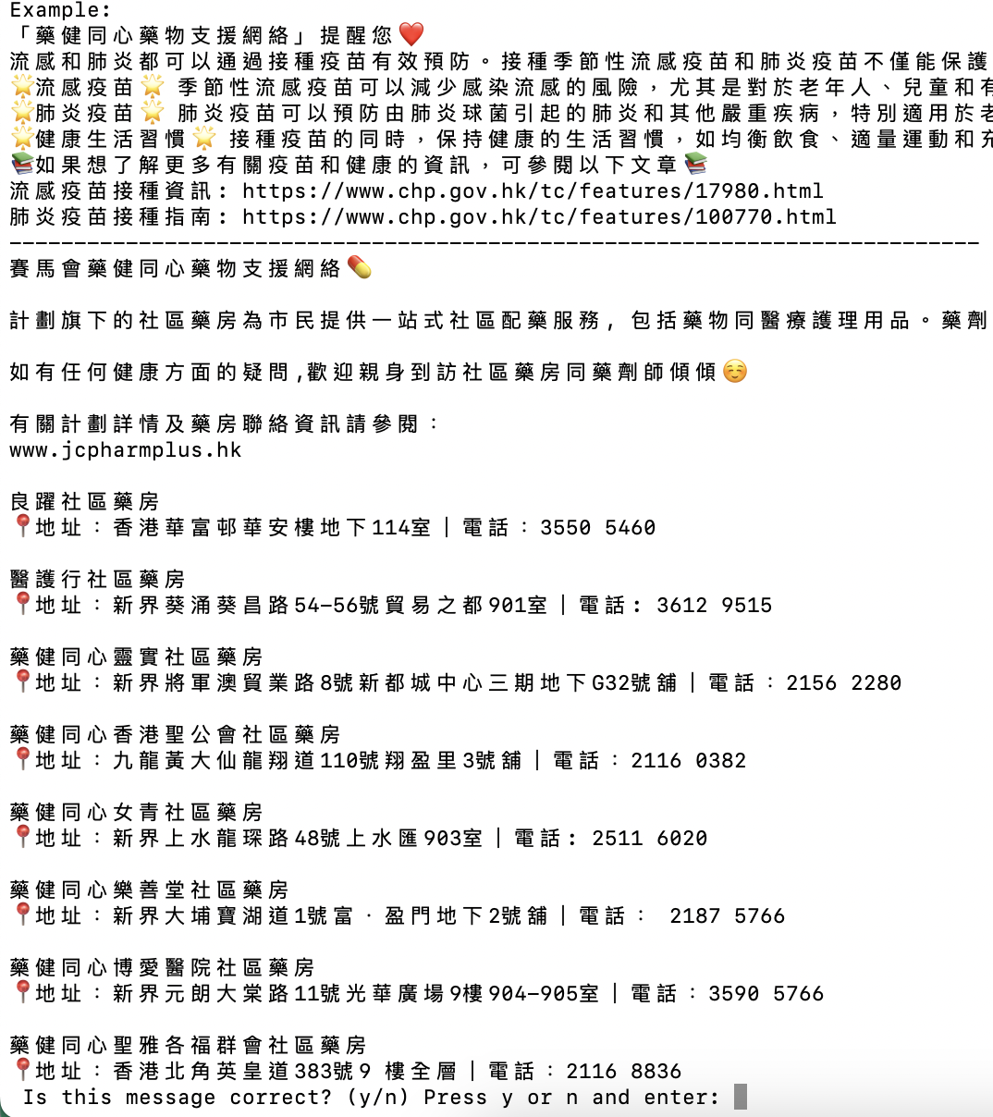

* Upon sending, the message will pop up in the terminal
* This is the message which will be sent to participants, so check thoroughly!
* If nothing looks off and its good to go, type ‘y’ and enter
* If something is off and its not good to go, type ‘n’ and enter
  + After typing ‘n’ and enter, the message will not be sent.
    - Repeat step 3 with the fixed message

## Step 4

* After confirming, this message will show:

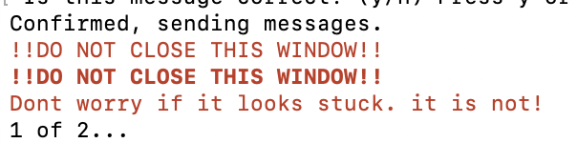

* ‘1 of 2’ means 1 participant out of the total of 2 participants have received the message. Depending on the amount of phone numbers in the excel file, the amount may be different.
* You may minimize the window and let it run in the background
* Sending messages takes time. Sometimes it may look stuck, but don’t close the terminal until you see this message:

